Subchondroplasty Rehabilitation Protocol
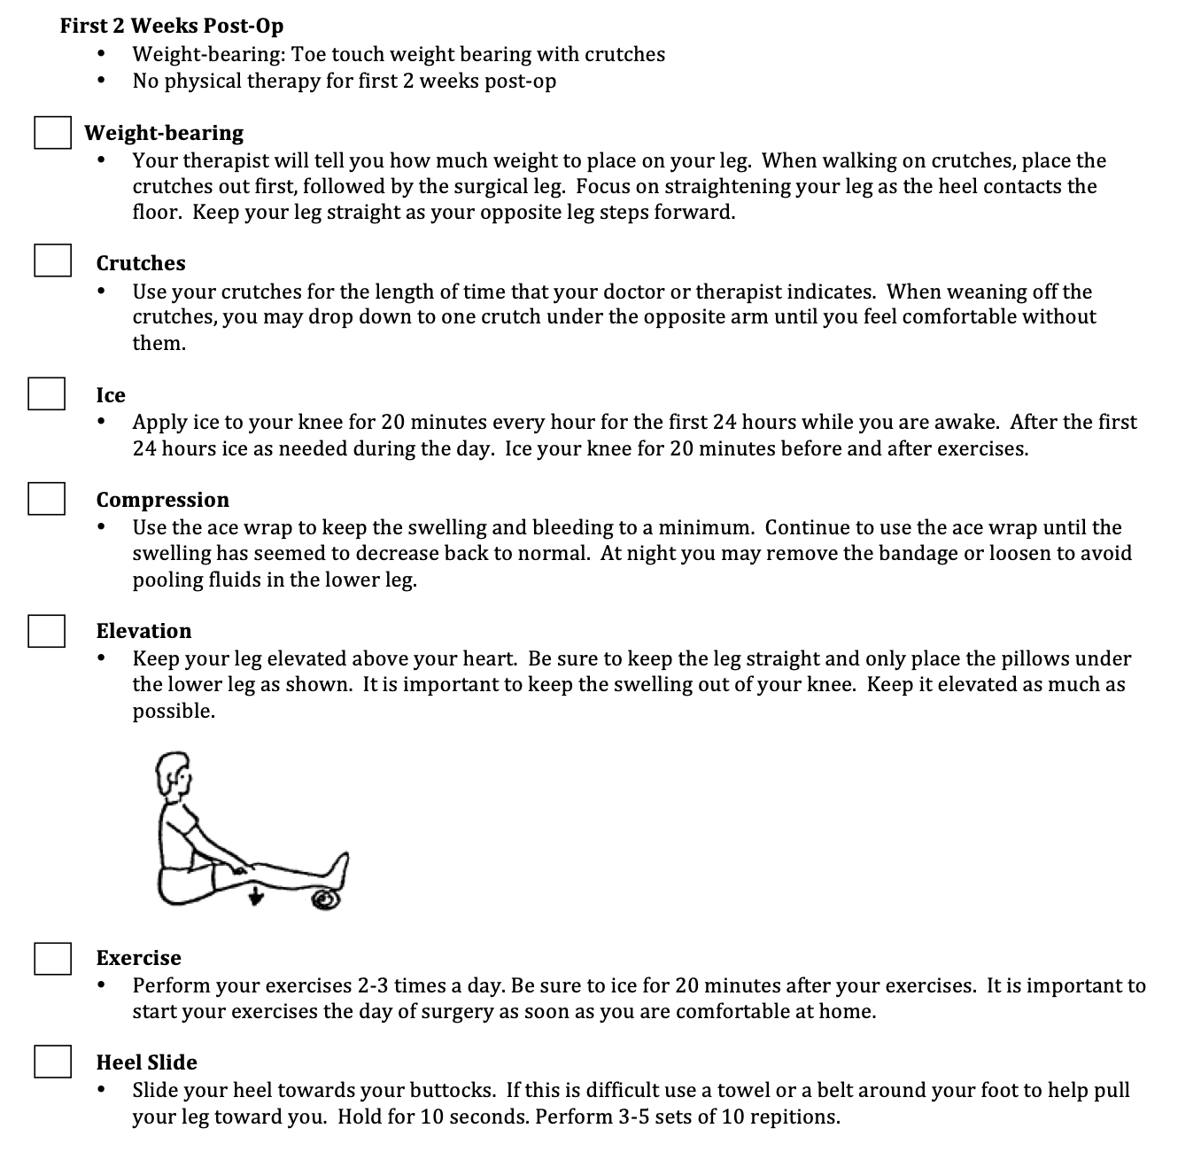

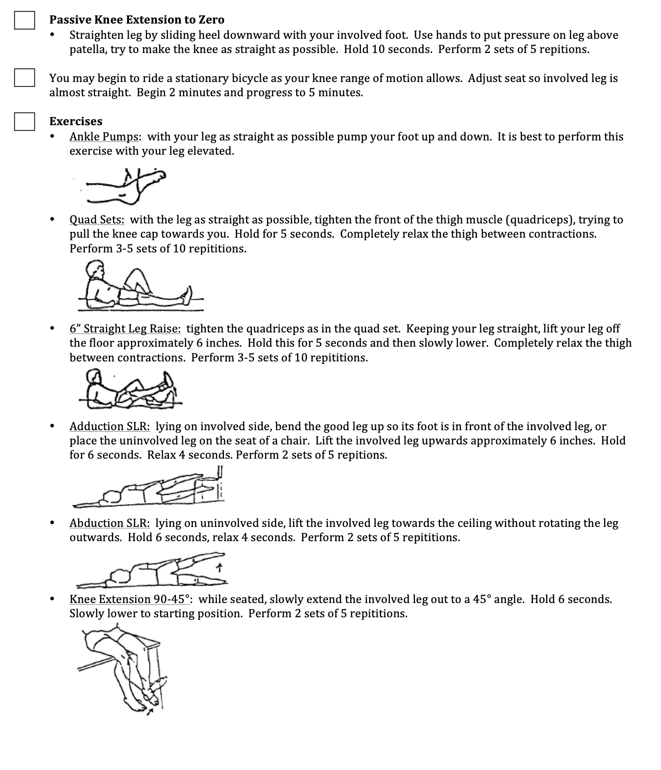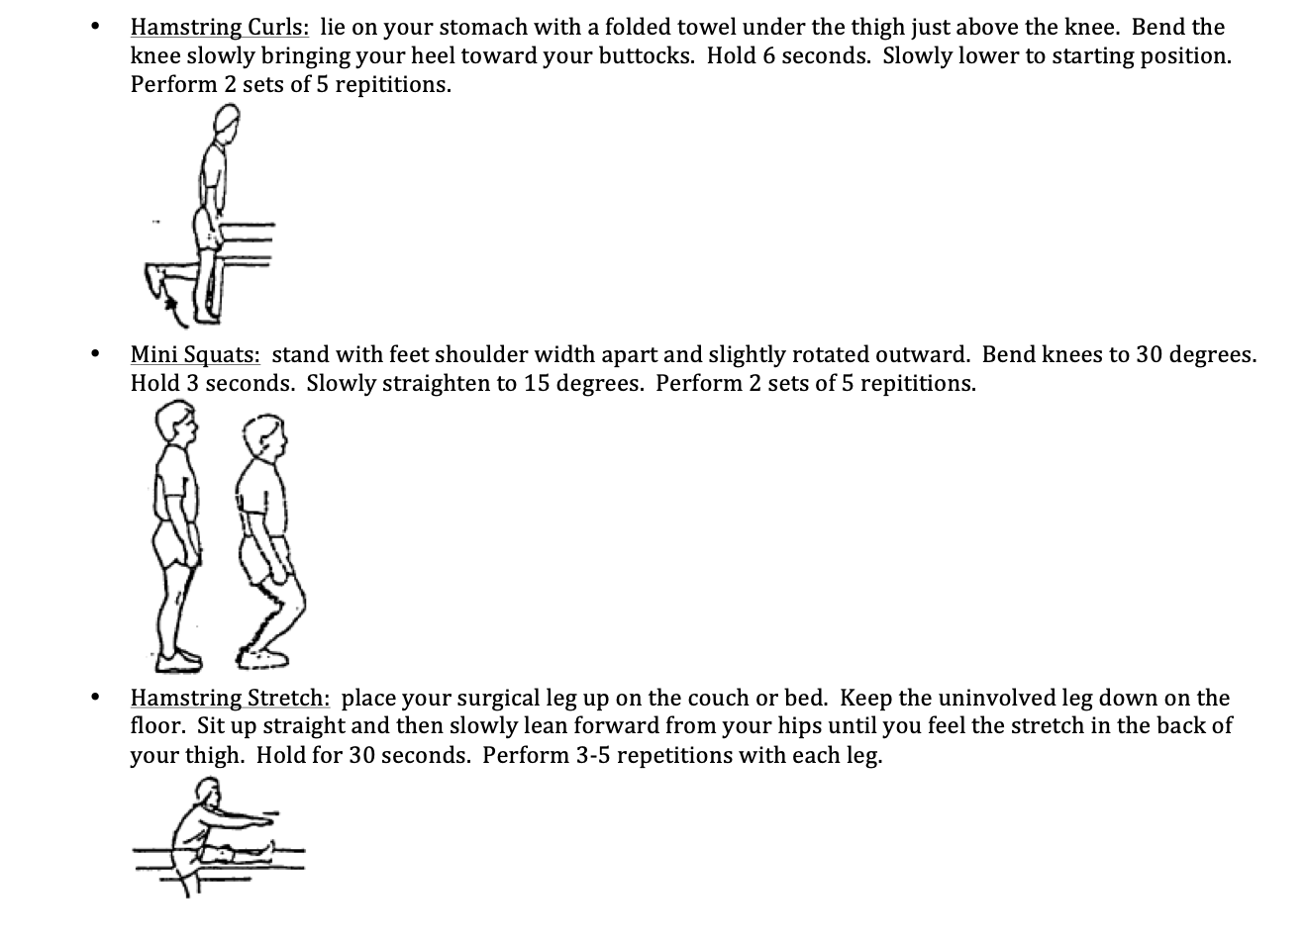

Phase I (0-2 weeks)
• TTWB
- No brace
- ROM: As tolerated
Exercises:
o Heel slides
o Quad/hamstring sets
o Straight leg raises
o Planks
o Bridges
o Abs
o Step Ups
o Stationary Bike
Phase II (2-4 weeks)
• WBAT
Exercises:
o Progress phase I exercises
o Add sports specific exercises
o Cycling, elliptical, running as tolerated
Phase III (4-12 weeks)
Exercises:
o Progress phase I exercises
o Add sports specific exercises
o Cycling, elliptical, running as tolerated
o Advance sports specific exercises
o Core, glut, hip and balance program maintenance

