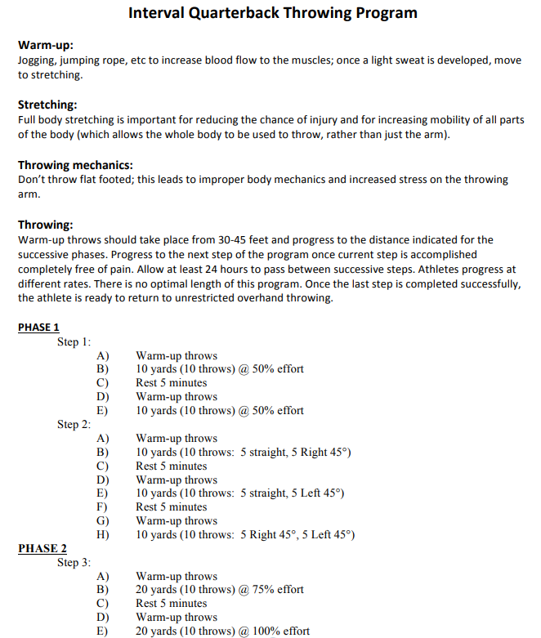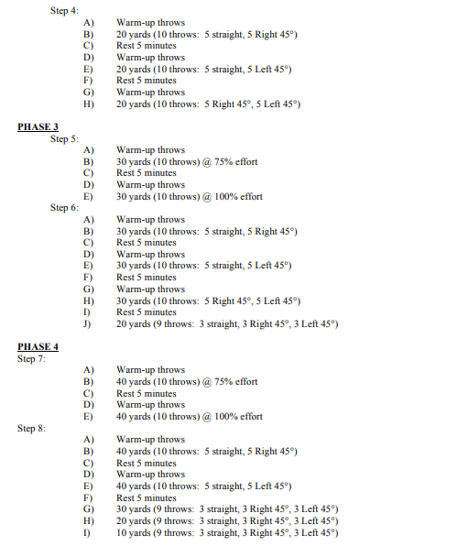
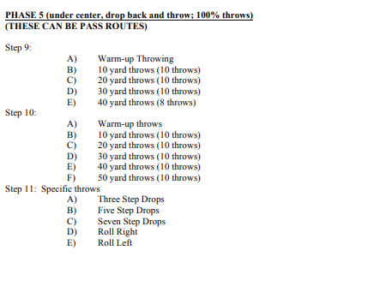

Christopher C. Vasileff, MD
Orthopaedic Sports & Shoulder Reconstruction Surgeon
Carolina Orthopaedic & Sports Medicine Center / Gastonia – Belmont
Office: 704-865-0077

